# CS 255 System Design Document

## UML Diagrams

### *Use case diagram.png*UML Use Case Diagram

### UML Activity Diagrams

Input Availability Use Case Practice Written Test Use Case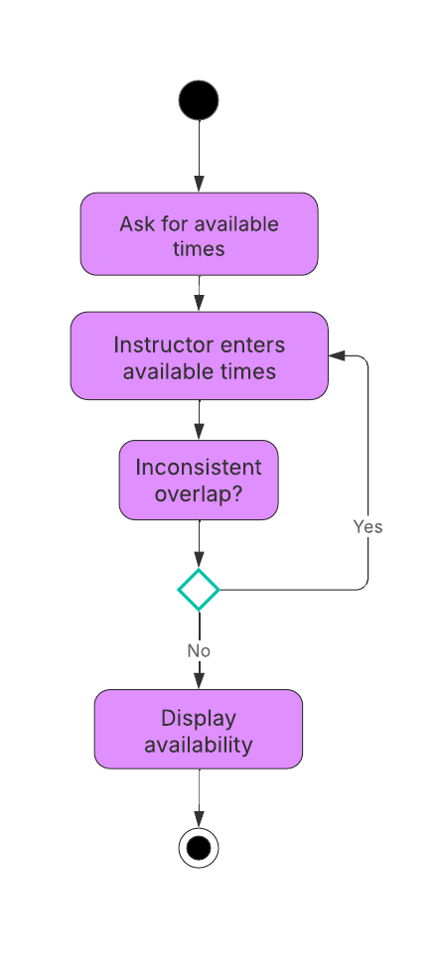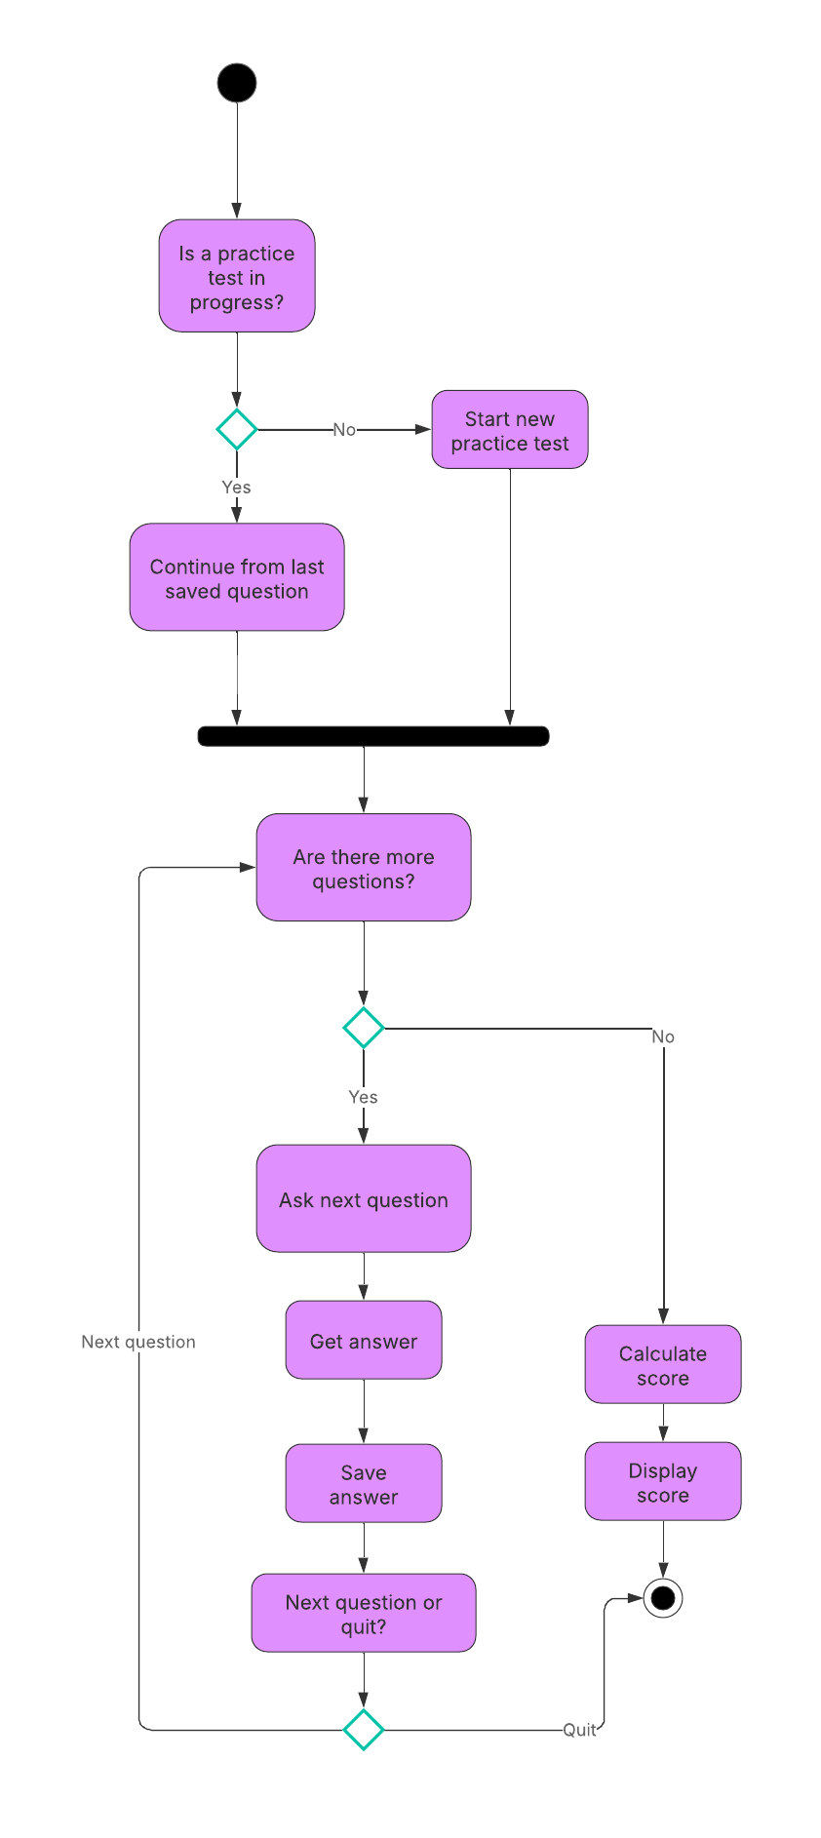

### UML Sequence Diagram

Input Availability Use Case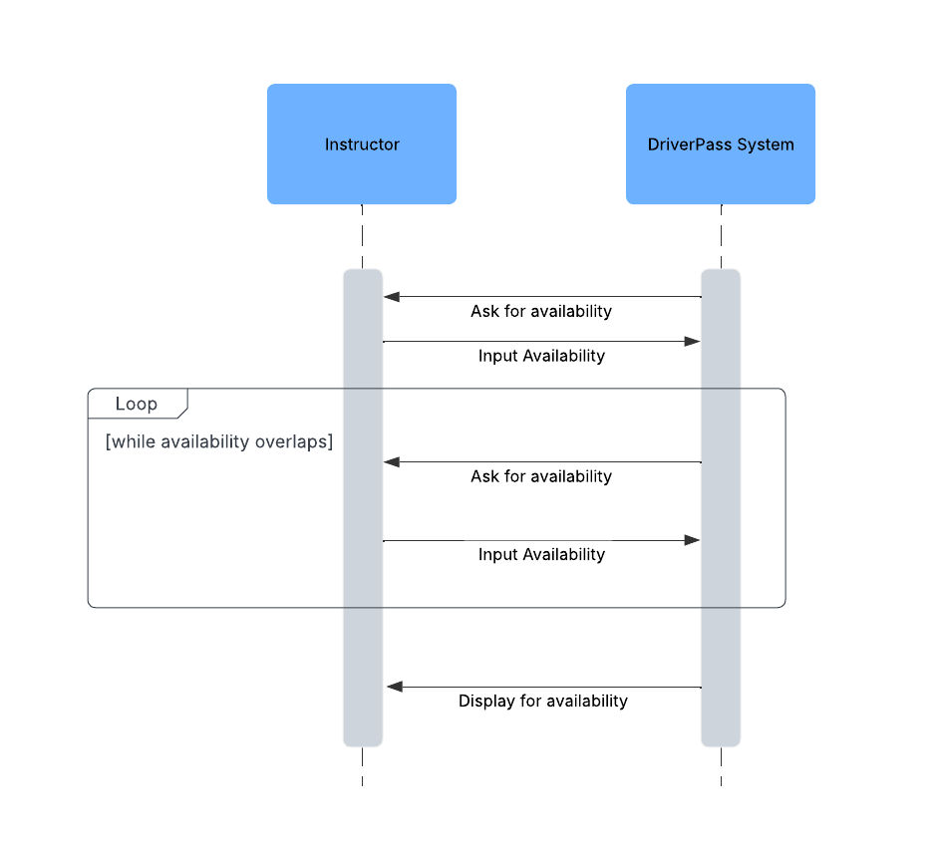

### UML Class Diagram

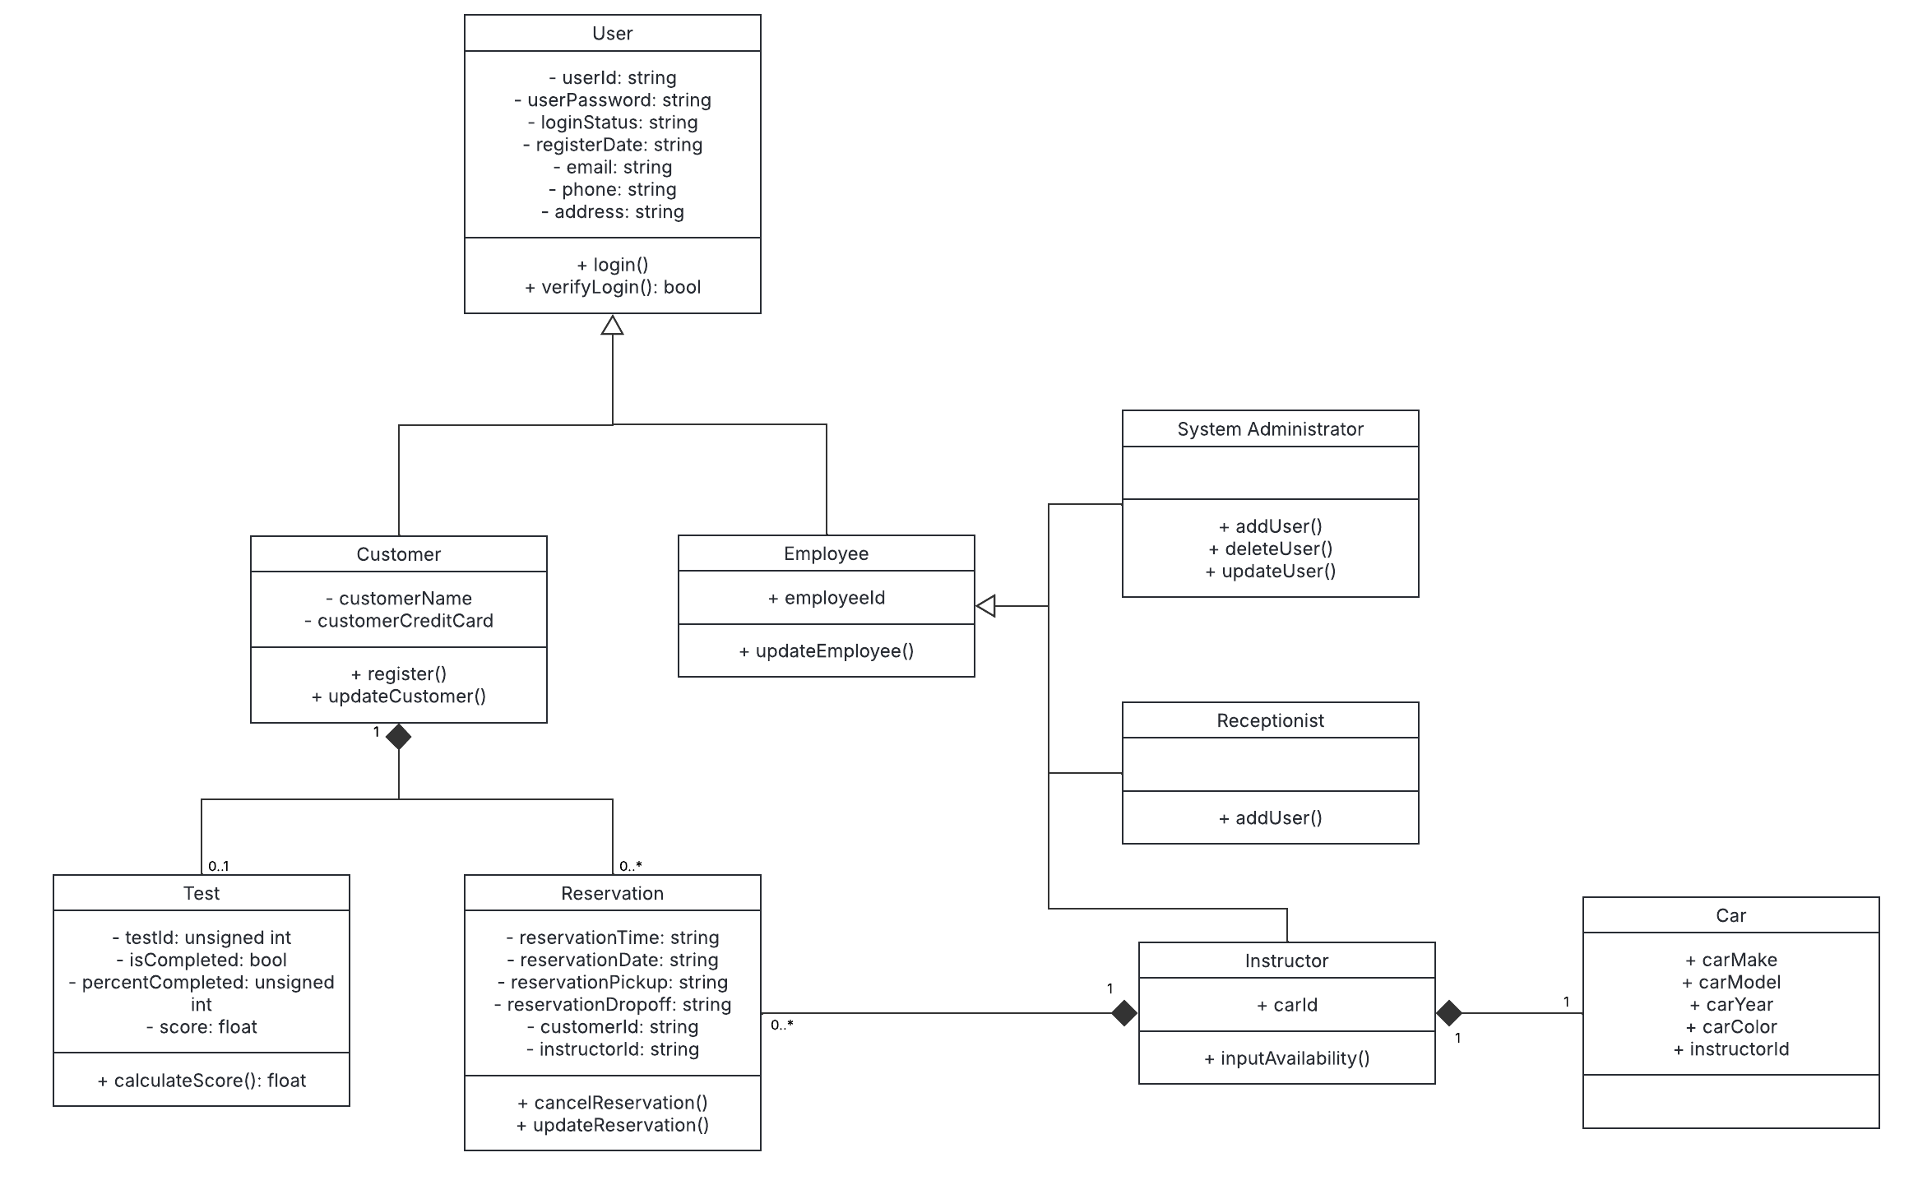

## Technical Requirements

* Cloud-based server that holds a database with user, test, and reservation information.
* The database will be built with SQLite.
* Client side will run on Apple and Android smartphones and Windows and Mac computers.
* Client side will be an application rather than browser-based.
* The system will use SymmetricDS to allow users to work offline.
* The system will be built primarily in Java.
* The system must not exceed 3 seconds when logging a user in.
* The system must perform without significant delays when multiple users access the system.